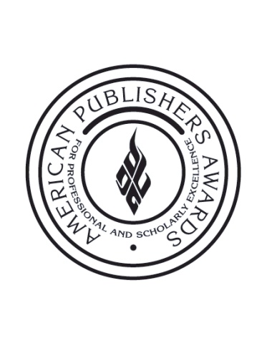

FOR IMMEDIATE RELEASE Contact:
Kate Kolendo
212.255.0326
kkolendo@publishers.org

PROSE Awards to Premiere Sixth Annual Short Film,
A Holy Curiosity: The Mind of a Scientist Author

New York, NY, January 27, 2014 – The Professional and Scholarly Publishing Division of the Association of American Publishers will debut its sixth annual short film during this year’s American Publishers Awards for Professional and Scholarly Excellence (PROSE) ceremony.

A Holy Curiosity: The Mind of a Scientist Author, tells the poignant story of one man’s quest to create an epic work of scholarship that wins PROSE’s vaunted Hawkins Award, the highest prize in scholarly publishing. The documentary goes behind the scenes with the author of the 2011 R.R. Hawkins Award winner, The Diffusion Handbook: Applied Solutions for Engineers. The film will premiere at the PROSE Awards ceremony held Thursday, February 6 at the Ritz-Carlton Hotel in Washington, DC. The Awards also will be seen live via webcast.

Directed and produced by award-winning New York filmmaker Mary Rose Synek, the film examines the creation of a highly acclaimed work of scholarship about the diffusion equation and its myriad everyday applications – from expansion and contraction of metals to growth of cancerous cells in the human body. Although diffusion has long been known to be fundamental to almost everything that happens on Earth, author Michael Thambynayagam spent his professional life creating the first authoritative resource on the subject. His equations explain the movement of particles from areas of high to low concentration that occurs in all aspects of life.

“The experience of working on the film brought to mind how interconnected one's life's work is to one's early experiences,” said filmmaker Synek. “Michael's trajectory is one of talent, determination, passion and stamina. He illustrates how a gifted person's vision can evolve into a coherent, useful and significant contribution. The Handbook is certainly a great work which will be utilized into the next century. I hope this film evokes a sense of awe and appreciation for Michael's seemingly tireless approach to completing his creation.”

The 2011 R.R. Hawkins Award, the top PROSE Awards honor, was presented to Thambynayagam and McGraw-Hill Professional for The Diffusion Handbook in February 2012. The book also won the PROSE Award for Excellence in Physical Sciences and Mathematics, as well as in the Engineering and Technology category.
“The Diffusion Handbook is the definitive work in its field,” explained PROSE Awards Chairman John A. Jenkins, President and Publisher Emeritus of CQ Press. “It is exceptional in its breadth and depth, addressing applications of the diffusion equation across areas of engineering, and it will surely prove to be the authoritative handbook that will influence and be used by engineers for many years to come. In other words, it is exactly the type of important work that PROSE should and does honor.”
In this 2013 award season, the PROSE Awards received a record high of 535 entries from more than 60 publishers across the United States and abroad. The judging panel, comprised of 14 editors, librarians, academics and publishers from across the globe, convened in New York City in early January to decide the winners in each category, including the prestigious R.R. Hawkins Award recognizing the most outstanding professional and scholarly work of 2013. For the first time in 2013, the Hawkins winner will receive a $10,000 cash prize for its author.

All 2013 honors will be awarded during the ceremony on February 6, which will be webcast live via www.proseawards.com. Followers can also track the winning entries as they are announced by following the #PROSEawards hashtag and @PROSEawards handle on Twitter.

About AAP
The Association of American Publishers is the national trade association of the U.S. book publishing industry. AAP’s more than 300 members include the major commercial publishers in the United States, as well as smaller and non-profit publishers, university presses and scholarly societies. AAP members publish hardcover and paperback books in every field; educational materials for the elementary, secondary, postsecondary, and professional markets; scholarly journals; computer software; and electronic products and services. The protection of intellectual property rights in all media, the defense of the freedom to read and the freedom to publish at home and abroad, and the promotion of reading and literacy are among the Association’s highest priorities. For more information on the PROSE Awards, please visit: www.proseawards.com. Follow award updates on Facebook and Twitter.

# # #

